TECHVISION SOLUTIONS


TECHVISION SOLUTIONS Monthly Company Newsletter September 2026
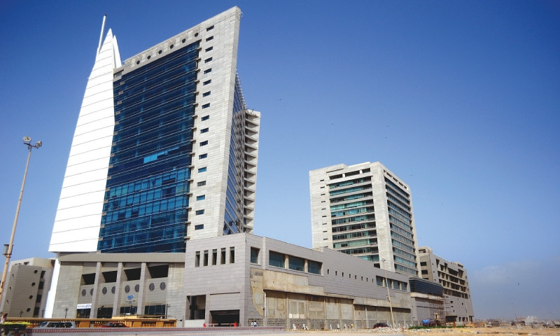
TECHVISION SOLUTIONS
MUHAMMAD KABIR
ROLL NO: 42401
DATE: 10/1/2026

ABOUT US:
Empowering businesses with seamless digital solutions. We specialize in advanced POS software for efficient retail and hospitality management. Our robust SaaS platforms deliver modern, scalable websites and online stores. TechVision Solutions bridges the gap between powerful technology and intuitive user experience.

EMPLOYEE DETAILS:
Employee Name | Department | Position | Salary
Ali Khan | IT | Developer | 85000
Sara Ahmed | HR | HR Officer | 70000
Hamza Malik | Marketing | Manager | 95000
Ayesha Noor | Finance | Accountant | 80000
Zain Abbas | IT | Web Developer | 75000

OUR Achievements:
- Successfully launched a new website
- Increased customer satisfaction
- Conducted employee training
- Added new clients
- Improved technical support
OUR GRAPHICS:


WE BUILD POS
WE BUILD SOFTWARE
WE BUILD SAAS
WE BUILD WEBSITES
TechVision Solutions – Company Newsletter
MUHAMMAD KABIR
ROLL NO: 42401
DATE: 10/1/2026

